South East Technological University

University App
Research Document

Prepared by:
Ihor Melashchenko (C00290950)
Bachelor of Science (Honours) in Software Development, Year 4
Supervisor:
Dr. Joseph Kehoe
19.05.2026

Acknowledgements
Thank you to the project supervisor and peer reviewers for iterative feedback on scope control and implementation quality.

Table of Contents
Acknowledgements 2
Abstract 5
1. Introduction 6
1.1 Problem Context 6
1.2 Similar Apps 6
2. Digital Student ID 12
3. Architecture 13
4. Technology Stack 14
5. Conclusion 15
Glossary 16
Bibliography 17

Figure 1. Apple Wallet with the digital student ID card 7
Figure 2. TCD members showcasing the Trinity ID App 8
Figure 3. ID123 IDMS 9
Figure 4. Several Ukrainian state-issued documents are available in the Diia app 10
Figure 5. Mriia's web interface 11
Figure 7. Use Case Diagram 16

Abstract
The University App is a multi-platform super-app (Haines, 2022) that consolidates student services into a single, unified platform. The long-term vision is that the application could operate as a configurable B2B (business-to-business) service for any higher education institution (HEI), similar to how Blackboard functions as a SaaS (Software as a Service) product.
For this project, the development focuses on the ecosystem of the South East Technological University (SETU), incorporating its branding, structure, and service offerings.
The application aims to address a widely recognized challenge across HEIs: fragmented student systems that require multiple logins, offer an inconsistent user experience, and have limited integration.
Project motto: “One app. One login. One student experience.”

1. Introduction

1.1 Problem Context
HEIs are reliant on digital ecosystems to support academic, administrative, and social engagement. This results in institutions often facing challenges of fragmentation, where multiple systems operate independently, such as learning management systems (LMS), virtual learning environments (VLE), student portals, email platforms, and printing services. This fragmentation reduces efficiency, creates barriers to seamless engagement, and contributes to poor user experience.
The University App aims to create an integrated mobile platform that unifies essential university services into a single application. It combines academic tools and identification services. The application seeks to improve accessibility, streamline authentication through a digital student ID card, and promote active participation through interactive components.
A main innovation within this application is the digital student ID card, which complements (but does not yet replace) the traditional plastic card. This digital identification mechanism will allow students to verify their identity, access facilities, and engage with the institution’s services directly from their smartphones. By integrating academic tools and identity verification into a cohesive mobile experience, the University App aims to deliver an accessible, modern, and cross-campus digital ecosystem for university students.

1.2 Similar Apps
A range of existing applications demonstrates how integrated digital ecosystems can enhance user experience in the educational context. For instance, some American colleges have incorporated the student ID into Apple Wallet (Terminalfour Higher Education Digital Marketing Blog, 2019).
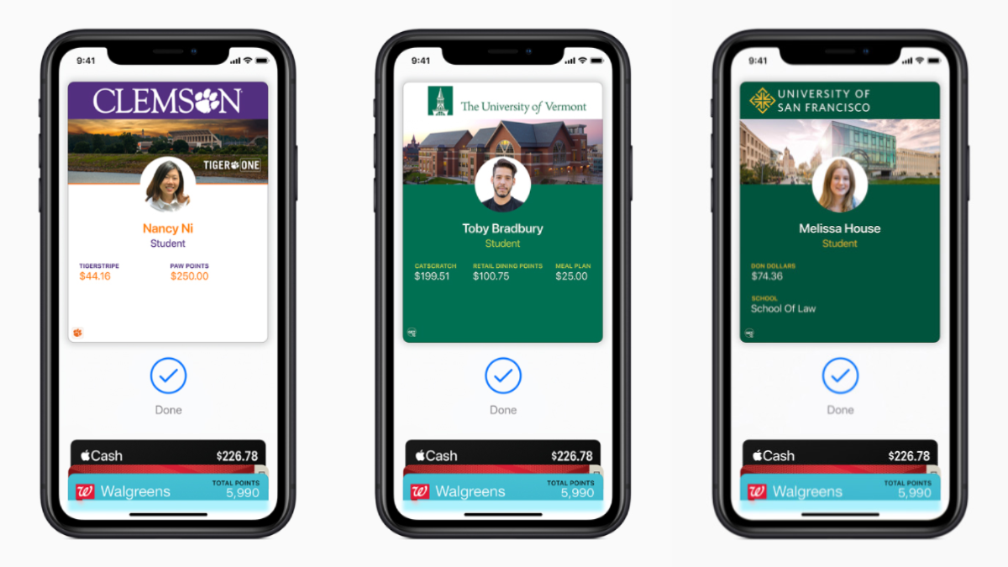
Figure 1. Apple Wallet with the digital student ID card
Several students from Trinity College Dublin (TCD), under the supervision of their professor and in collaboration with the IT department, have surveyed the use of the student ID card by the students and developed an application that features a digital student ID card (Dublin, 2026).

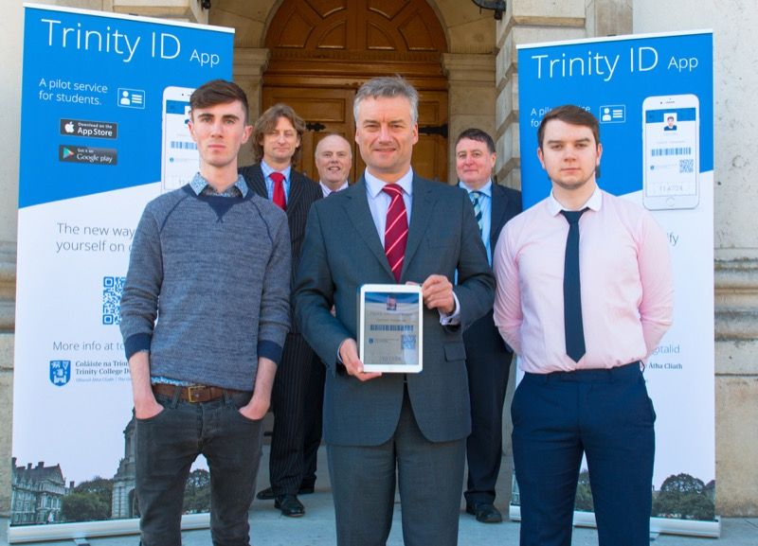
Figure 2. TCD members showcasing the Trinity ID App
ID123, a private American company, has developed an ID Management System (IDMS) and is providing a digital ID solution to businesses and educational institutions (ID123, 2026).
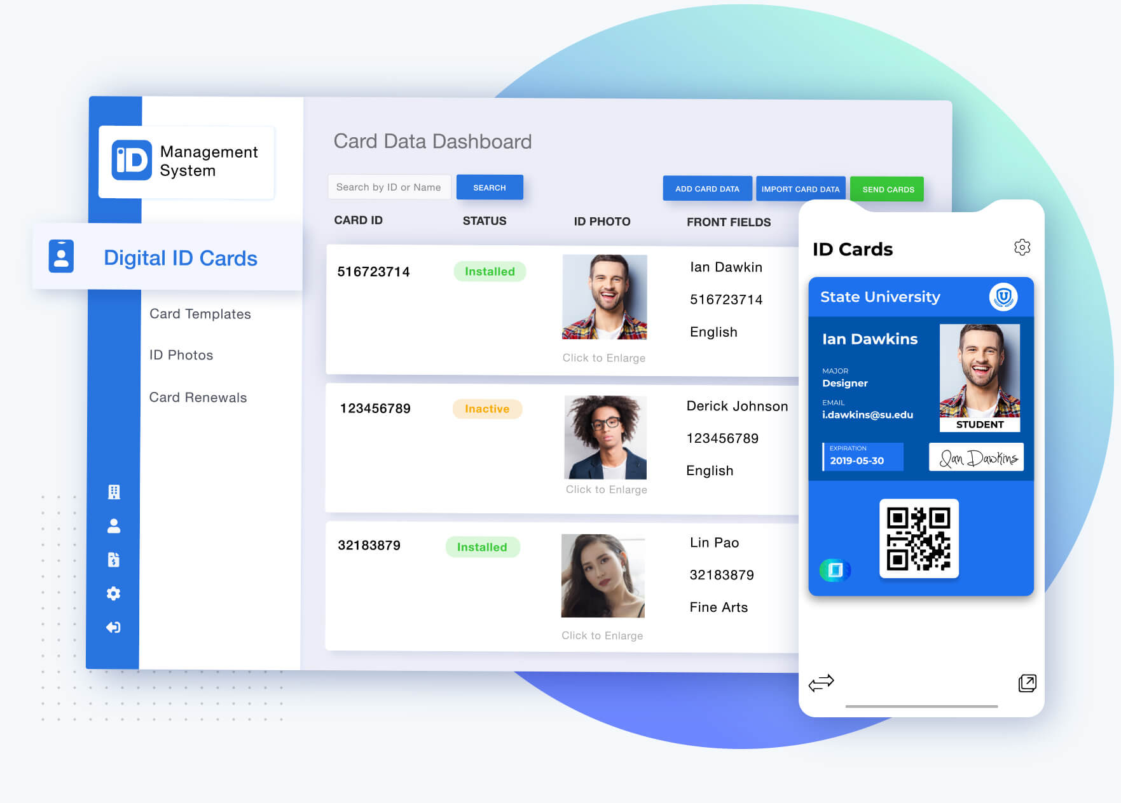
Figure 3. ID123 IDMS
In 2021, Ukraine became the first country in the world to fully legalise digital state IDs and passports that were developed as part of the government ecosystem called Diia, developed by the Ministry of the Digital Transformation of Ukraine (Diia.gov.ua, 2018).
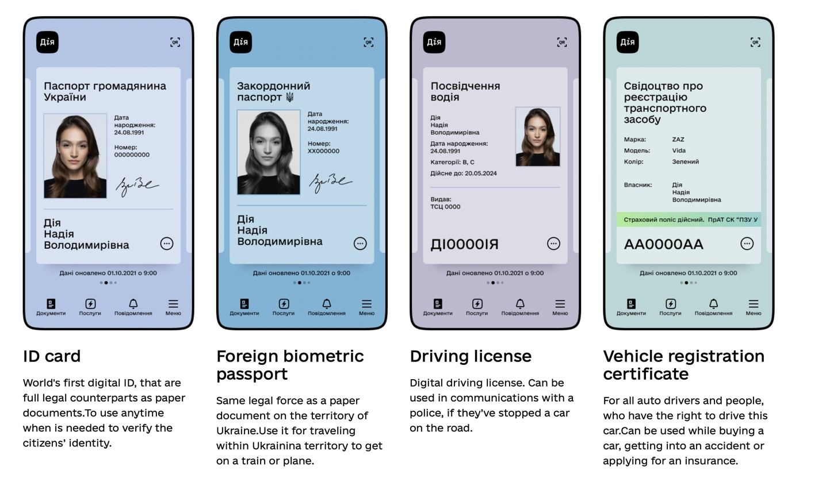
Figure 4. Several Ukrainian state-issued documents are available in the Diia app
Following Diia’s success, the Ukrainian government developed a state educational ecosystem called Mriia in 2023. It was adopted by many Ukrainian schools, thus providing a convenient digital solution for students, their parents, and teachers (Mriia.gov.ua, 2024).

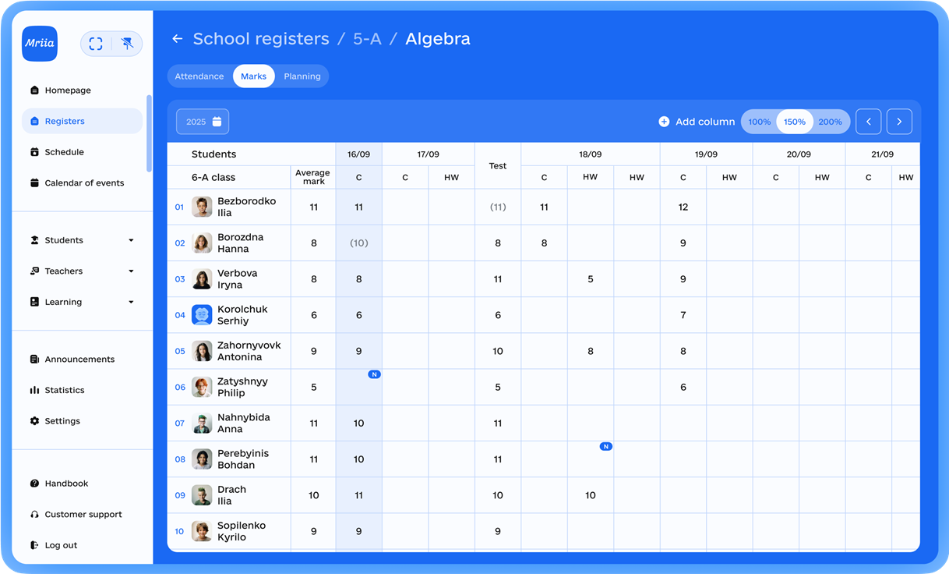
Figure 5. Mriia's web interface

2. Digital Student ID
The digital student ID is a core innovation: a secure, signed, mobile-first representation of a student’s institutional identity that complements the physical card. Its goals are availability, verifiability, preservation of privacy, and minimal complexity.
- Functionality: displays student name, photo, course, and membership data; supports on-device presentation for library gates; exposes a server-validated QR and barcode payloads for programmatic checks.
- Verification model: server issues a signed payload (compact JSON) encoded into a QR and barcode. Verification endpoints validate signatures and account status. For offline-present use-cases, short-lived signed tokens and timestamps can support local checks with minimal exposure.
- Privacy: signing keys and token issuance occur server-side; payloads include a timestamp to mitigate replay and use TLS while in transit.
- Interoperability: the design anticipates future integration with Apple Wallet and Google Wallet pass formats, while initial delivery targets the native iOS client.
Implementation evidence for QR and barcode issuance and verification exists under “server/backend/handler/qr_handler.go”.

3. Architecture
The system follows a layered, component-based architecture with a single API boundary and clear client/service separation.
- Clients: native iOS student client (Swift UI) and an admin web SPA (React and Vite).
- API layer: Go service implementing routing, middleware, authentication, and business handlers.
- Services: domain services encapsulate business logic (QR and barcode issuance, card request lifecycle, assignment management).
- Persistence: PostgreSQL holds canonical domain records; migrations in “server/backend/migrations” provide traceable schema evolution.
- Deployment: Docker Compose for local orchestration; container images and Kubernetes manifests in “server/k8s” for cluster deployment.
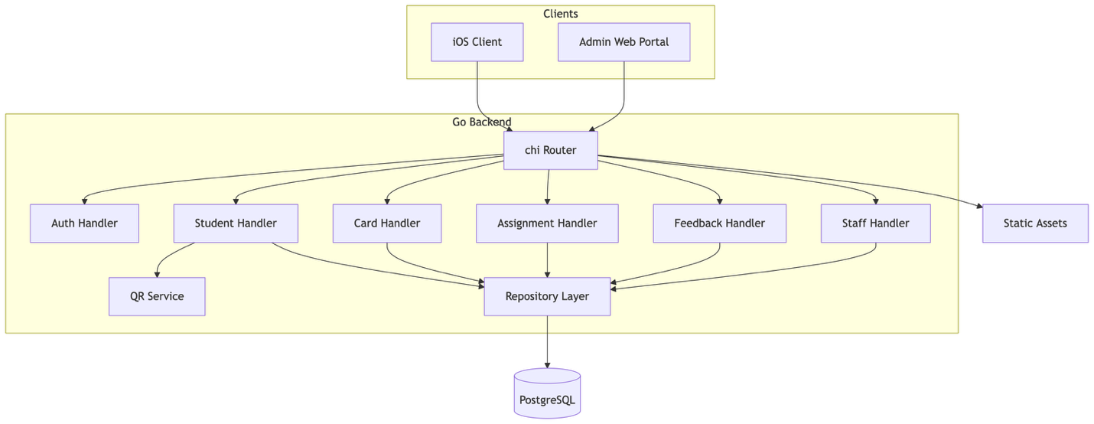
Figure 6. Component Architecture
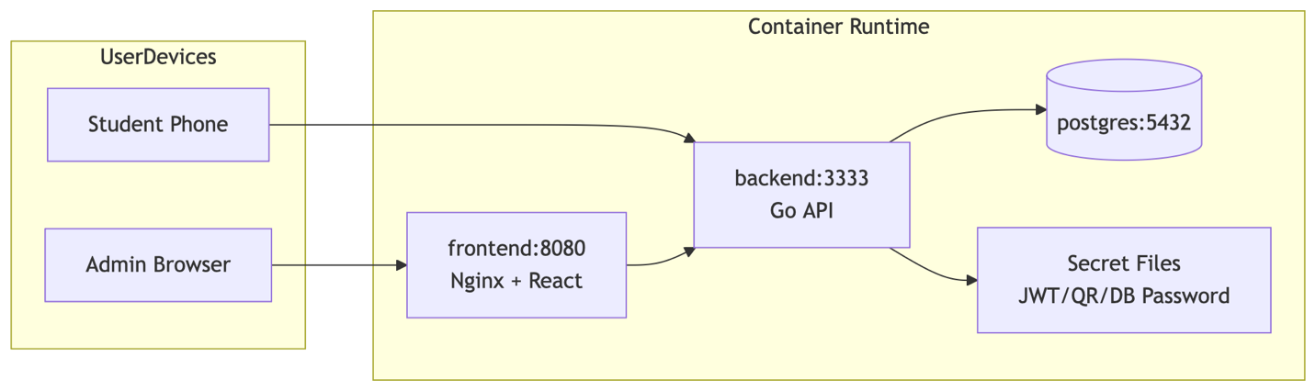
Figure 7. Deployment Diagram

4. Technology Stack
- Backend: Go, chi router, standard HTTP, and middleware patterns.
- Database: PostgreSQL with SQL migration files.
- Authentication and Security: JWT for tokens, bcrypt for password hashing, server-side signing for QR and barcode payloads.
- Mobile client: Swift and SwiftUI for iOS.
- Admin frontend: React and Vite; Nginx for static serving and proxying.
- DevOps: Docker Compose, Docker images, Kubernetes manifests (kustomize overlays).
Tooling and evidence: “server/backend/go.mod”, “server/frontend/package.json”, “vite.config.js”, and “server/compose.yaml” are in the repository to link decisions to artifacts.

5. Conclusion
The University App combines a cutting-edge technology stack and a future-proofed architecture to deliver a secure digital student ID and consolidated student services, creating an ecosystem. The research and implementation prioritise three measurable outcomes: security and verifiability of identity workflows, evidence linking design decisions to code, and an achievable delivery suitable for a final-year project.
Key findings
- Identity: A server-signed QR-based ID model provides a verifiable, low-complexity presentation layer that is sufficient for campus services access and security checks; platform wallet integration (Apple Wallet/Google Wallet) is feasible but out of scope for this project.
- Architecture: A single API boundary (Go + chi router) with domain services and PostgreSQL for persistent storage provides a clear separation of concerns, simple testing paths, and compact deployment artefacts that are easy to inspect for assessment.
- Usability and delivery: Native iOS (Swift and SwiftUI) client for students and an admin SPA (React) balances UI/UX quality with implementation effort, resulting in a demonstrable user experience within the project timeline.
Limitations and risks
- Scope limits multi-platform variability: Android and Web clients remain future work.
- Security is limited: While JWT, signed payloads, and bcypt provide solid fundamental controls, enterprise-grade IAM and third-party audits are outside of the project scope.
- Operational readiness: The current delivery focuses on a functional demo; production concerns (scaling, monitoring, alerting, etc.) are outside of the project scope.
Recommendations and next steps
- Test evidence: Complete end-to-end integration tests for QR and barcode issuance/verification, authentication, and card-request lifecycles; collect p95 timing samples in a test environment.
- Usability tests: A small group of test users (5-10 people) to gather feedback on the digital student ID card functionality; use findings to prioritise UI refinements.
- Cross-platform: Create a minimal Android client to broaden the platform coverage.
- Operational improvement: Add secrets management functionality and simple alerting for different health checks.
This project demonstrates a viable product that has the potential for a consolidation with the existing HEIs infrastructures.

Glossary
- API: Application Programming Interface
- JWT: JSON Web Token
- p95: 95th percentile response time

Bibliography
Haines, J. (2022). The Super-app Experience. [online] Medium. Available at: https://uxplanet.org/the-super-app-experience-3fd530ac1e5f.
Terminalfour Higher Education Digital Marketing Blog. (2019). Blog - Apple rolls out contactless student IDs to 12 more universities. [online] Available at: https://www.terminalfour.com/blog/posts/apple-rolls-out-contactless-student-ids-to-12-more-universities.html.
Dublin, T.C. (2026). New Trinity ID App. [online] www.tcd.ie. Available at: https://www.tcd.ie/news_events/articles/new-trinity-id-app/.
ID123. (2026). Digital ID Cards. [online] Available at: https://www.id123.io.
Diia.gov.ua. (2018). Digital State. [online] Available at: https://expo.diia.gov.ua.
Mriia.gov.ua. (2024). Мрія — перший освітній державний застосунок для учнів, батьків і вчителів. [online] Available at: https://mriia.gov.ua/en/app.

